Problem Statement 3 - Agentic AI Video Call–Based Onboarding

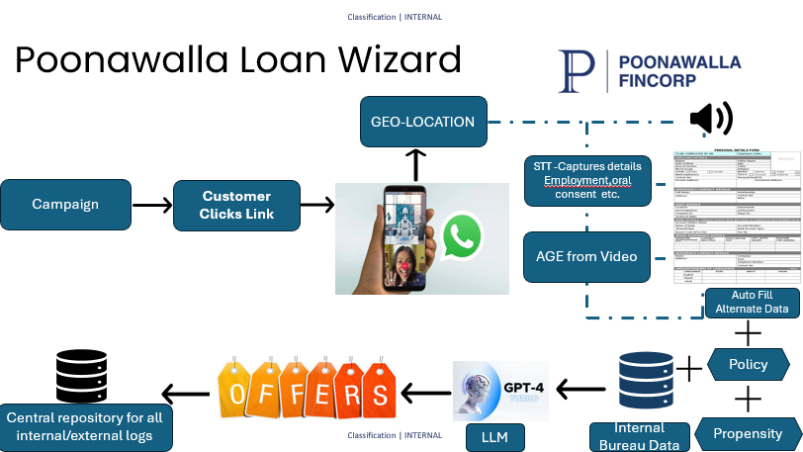
Poonawalla Fincorp Loan Wizard

Video-Based Digital Loan Origination & Risk Assessment System

1. Problem Statement
Traditional digital loan journeys face challenges such as high drop-offs, fraud risks, incomplete data capture, and limited contextual understanding of customers. Manual KYC processes add operational overhead, while purely form-based applications lack real-time verification and intent validation.
There is a need for a secure, compliant, and intelligent loan origination system that can:
- Digitally onboard customers in real time
- Capture consent and eligibility signals accurately
- Reduce fraud and misrepresentation
- Generate instant, personalized loan offers with minimal human intervention

2. Detailed Description
The Video-Based Digital Loan Origination System enables end-to-end loan onboarding, verification, risk assessment, and offer generation using a live video call as the primary interaction channel.

2.1 Key Functional Flow

2.1.1 Customer Entry via Campaign
- Customers access the system through a secure link shared via SMS, WhatsApp, email, or digital campaigns.
- The link initiates a controlled video call session.

2.1.2 Video Call–Based Data Capture
During the live video interaction, the system captures:
- Live video and audio streams
- Geo-location of the customer for compliance and fraud checks
- Session metadata (device, timestamp, IP)

2.1.3 Speech-to-Text (STT) & Consent Capture
- Customer responses during the call are converted into text using STT services.
- Key information extracted:
  - Employment details
  - Income declaration
  - Loan purpose
  - Explicit verbal consent
- Creates an auditable consent trail.

2.1.4 Computer Vision–Based Age Estimation
- Facial analysis estimates customer age from the video feed.
- Acts as a validation signal against declared age and policy thresholds.

2.1.5 Auto-Fill & Alternate Data Generation
- Extracted data auto-fills application forms.
- Reduces manual input and onboarding time.

2.1.6 Risk & Policy Evaluation
The system consumes:
- Internal bureau data (historical loan performance)
- Policy rules (eligibility, limits, exclusions)
- Propensity and risk scores (ML models)

2.1.7 LLM-Based Intelligence Layer
- An LLM interprets conversational context and normalizes unstructured inputs.
- Performs customer classification (risk band, persona, confidence indicators).
- Outputs structured intelligence without overriding deterministic rules.

2.1.8 Offer Generation
Based on policy, risk, and LLM insights, the system generates content of offers:
- Eligible loan amount(s)
- Tenure options
- Interest rates
- EMI structures

2.1.9 Central Logging & Audit Repository
- Stores video recordings, transcripts, geo-data, decisions, and offers.
- Ensures regulatory compliance, traceability, and audit readiness.

3. Judging Criteria
The solution will be evaluated based on:

3.1 End-to-End Digitisation
- Seamless onboarding with minimal manual intervention
- Fully paperless loan journey

3.2 Accuracy & Compliance
- Adherence to KYC and regulatory standards

3.3 Risk Mitigation
- Ability to detect fraud signals (location mismatch, age inconsistency)
- Robust policy and risk enforcement

3.4 Intelligence & Personalization
- Effective use of AI/LLM for contextual understanding
- Quality and relevance of generated loan offers

3.5 Scalability & Reliability
- Architecture supports high concurrency
- Low latency for real-time decisioning

4. Data Format

4.1 Input Data
- Video stream (live)
- Audio stream
- Geo-location coordinates
- Customer verbal responses
- Internal bureau records
- Policy configurations

4.2 Intermediate Data
- STT transcripts
- Age estimation scores
- Risk and propensity scores
- LLM classification outputs

4.3 Output Data
- Personalized loan offers
- Eligibility status
- Decision explanations
- Audit logs and consent records

